**MODUL PRAKTIKUM 4**

**ANALISIS ALGORITMA**



**Disusun oleh :**

Syaina Nur Fauizyah 140810170025

**PROGRAM STUDI S1 TEKNIK INFORMATIKA**

**FAKULTAS MATEMATIKA DAN ILMU PENGETAHUAN ALAM**

**UNIVERSITAS PADJADJARAN**

**2019**

1. Merge Sort

Source code:

/*

Nama : Syaina Nur Fauziyah

NPM : 140810170025

*/

#include <iostream>

using namespace std;

void merge(int arr[], int left, int middle, int right)

{

int i, j, k;

int n1 = middle - left + 1;

int n2 = right - middle;

int kiri[n1], kanan[n2];

for (i = 0; i < n1; i++)

kiri[i] = arr[left + i];

for (j = 0; j < n2; j++)

kanan[j] = arr[middle + 1+ j];

i = 0;

j = 0;

k = left;

while (i < n1 && j < n2)

{

if (kiri[i] <= kanan[j])

{

arr[k] = kiri[i];

i++;

}

else

{

arr[k] = kanan[j];

j++;

}

k++;

}

while (i < n1)

{

arr[k] = kiri[i];

i++;

k++;

}

while (j < n2)

{

arr[k] = kanan[j];

j++;

k++;

}

}

void mergeSort(int arr[], int left, int right)

{

if (left < right)

{

int middle = left+(right-left)/2;

mergeSort(arr, left, middle);

mergeSort(arr, middle+1, right);

merge(arr, left, middle, right);

}

}

void printArray(int arr[], int size)

{

for (int i=0; i < size; i++)

cout<<arr[i]<<" ";

cout<<"\n";

}

int main()

{

cout<<"=============================\n";

cout<<"Merge Sort";

int arr[] = {33,22,45,12,66,2,4,22};

int arr_size = sizeof(arr)/sizeof(arr[0]);

cout<<"Sebelum di sorting \n";

printArray(arr, arr_size);

mergeSort(arr, 0, arr_size - 1);

cout<<"\nSetelah di sorting \n";

printArray(arr, arr_size);

cout<<"=============================\n";

return 0;

}

ScreenShoot:

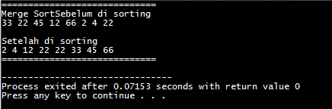

Kompleksitas Algoritma merge sort adalah O(n lg n).

1. Selection Sort

Source Code:

/*

Nama : Syaina Nur Fauziyah

NPM : 140810170025

*/

#include <iostream>

using namespace std;

int data[100],data2[100];

int n;

void tukar(int a, int b)

{

int t;

t = data[b];

data[b] = data[a];

data[a] = t;

}

void selection_sort()

{

int pos,i,j;

for(i=1;i<=n-1;i++)

{

pos = i;

for(j = i+1;j<=n;j++)

{

if(data[j] < data[pos]) pos = j;

}

if(pos != i) tukar(pos,i);

}

}

int main()

{

cout << "\n=====================================";

cout<<"\nMasukkan Jumlah Data : ";cin>>n;

cout << "\n-------------------------------------" << endl;

for(int i=1;i<=n;i++)

{

cout<<"Masukkan data ke-"<<i<<" : ";

cin>>data[i];

data2[i]=data[i];

}

selection_sort();

cout << "\n-------------------------------------" << endl;

cout<<"Data Setelah di Sort : ";

for(int i=1; i<=n; i++)

{

cout<<" "<<data[i];

}

cout << "\n=====================================\n";

}

ScreenShoot:

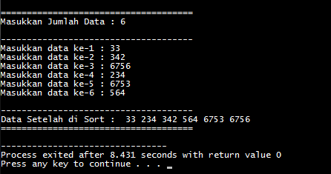

Menentukan T(n):

$$T\left(n\right)=\left(n-1\right)+\left(n-2\right)+…+1=\sum_{k=1}^{n-1}{n-k=\frac{n\left(n-1\right)}{2}}$$

Oleh Karena itu:

$$T\left(n\right)=O(n^{2})$$

$$T\left(n\right)=Ω(n^{2})$$

Karena $O\left(n^{2}\right)= Ω(n^{2})$,Maka $⊙(n^{2})$

1. Insertion Sort

Source code:

/*

Nama : Syaina Nur Fauziyah

NPM : 140810170025

*/

#include <iostream>

using namespace std;

int data[100],data2[100],n;

void insertion_sort()

{

int temp,i,j;

for(i=1;i<=n;i++){

temp = data[i];

j = i -1;

while(data[j]>temp && j>=0){

data[j+1] = data[j];

j--;

}

data[j+1] = temp;

}

}

int main()

{

cout << "\n=================================="<<endl;

cout<<"Masukkan Jumlah Data : "; cin>>n;

cout<<endl;

cout << "\n----------------------------------" << endl;

for(int i=1;i<=n;i++)

{

cout<<"Masukkan data ke-"<<i<<" : ";

cin>>data[i];

data2[i]=data[i];

}

cout << "\n----------------------------------" << endl;

insertion_sort();

cout<<"\nData Setelah di Sort : "<<endl;

for(int i=1; i<=n; i++)

{

cout<<data[i]<<" ";

}

cout << "\n=================================="<<endl;

}

ScreenShoot:

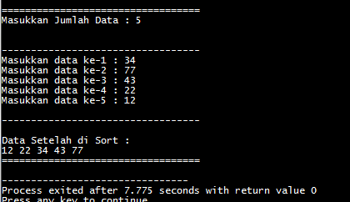

Menentukan T(n):

$$T\left(n\right)=2\left(1\right)+2\left(2\right)+2\left(3\right)+2\left(4\right)…+2\left(n-1\right)=2\left(1+2+3+4+…\left(n-1\right)\right)=\frac{2\left(\left(n-1\right)n\right)}{2}=\left(n-1\right)n=n^{2}-n=O(n^{2})$$

T(n) = $Ω\left(5\right)$

1. Bubble Sort

Source Code:

/*

Nama : Syaina Nur Fauziyah

NPM : 140810170025

*/

#include <iostream>

using namespace std;

int main(){

int arr[100],n,temp;

cout << "\n================================================"<<endl;

cout<<"Massukan banyak elemen yang akan diinputkan : ";cin>>n;

cout << "\n------------------------------------------------" << endl;

for(int i=0;i<n;++i){

cout<<"Masukkan Elemen ke-"<<i+1<<" : ";cin>>arr[i];

}

for(int i=1;i<n;i++){

for(int j=0;j<(n-1);j++){

if(arr[j]>arr[j+1]){

temp=arr[j];

arr[j]=arr[j+1];

arr[j+1]=temp;

}

}

}

cout << "------------------------------------------------" << endl;

cout<<"\nHasil dari Bubble Sort : "<<endl;

for(int i=0;i<n;i++){

cout<<" "<<arr[i];

}

cout << "\n================================================"<<endl;

}

ScreenShoot:

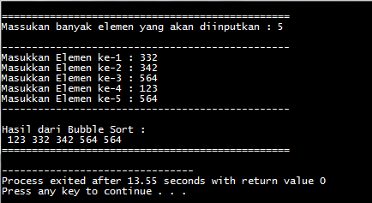

Menentukan T(n):

$$T\left(n\right)=n^{2}+n=O(n^{2})$$

$$T\left(n\right)=n-1=Ω(n)$$